CO-OPERATIVES 2020: MEMBERSHIP & THE LEARNING CIRCLE (PILOT PROJECT 2011/12)
- Pilot Project Process
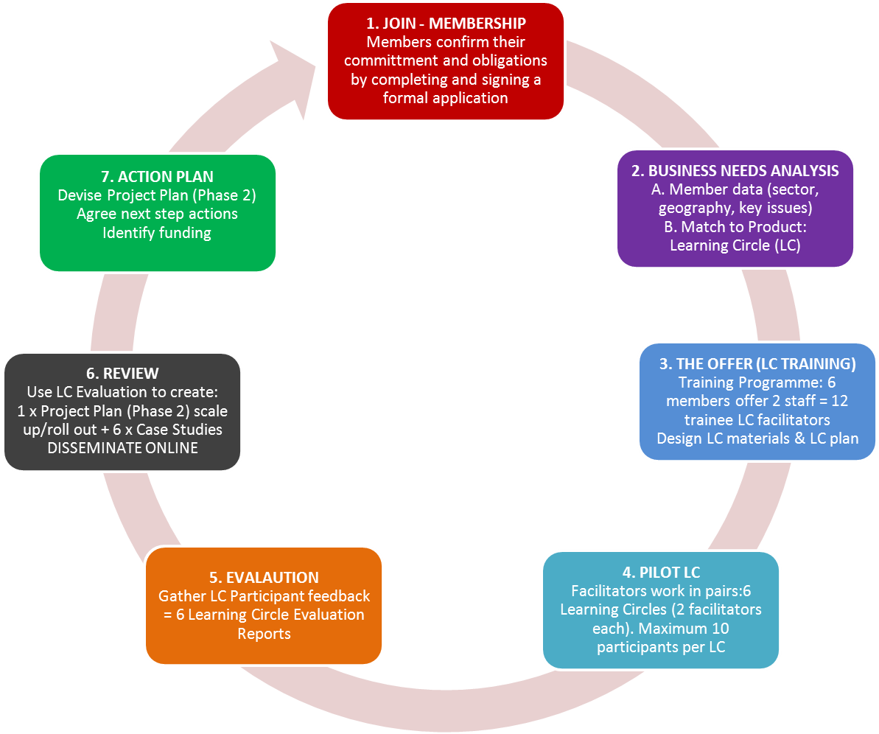

- Pilot Project Documents for each stage of the process...

